Task – 1: Create a Policy assignment
Step 1: In this task we are configuring a policy to make tag for a resource necessary, for that the current policy assignments are displayed, and I’ll create a new policy in the next step.
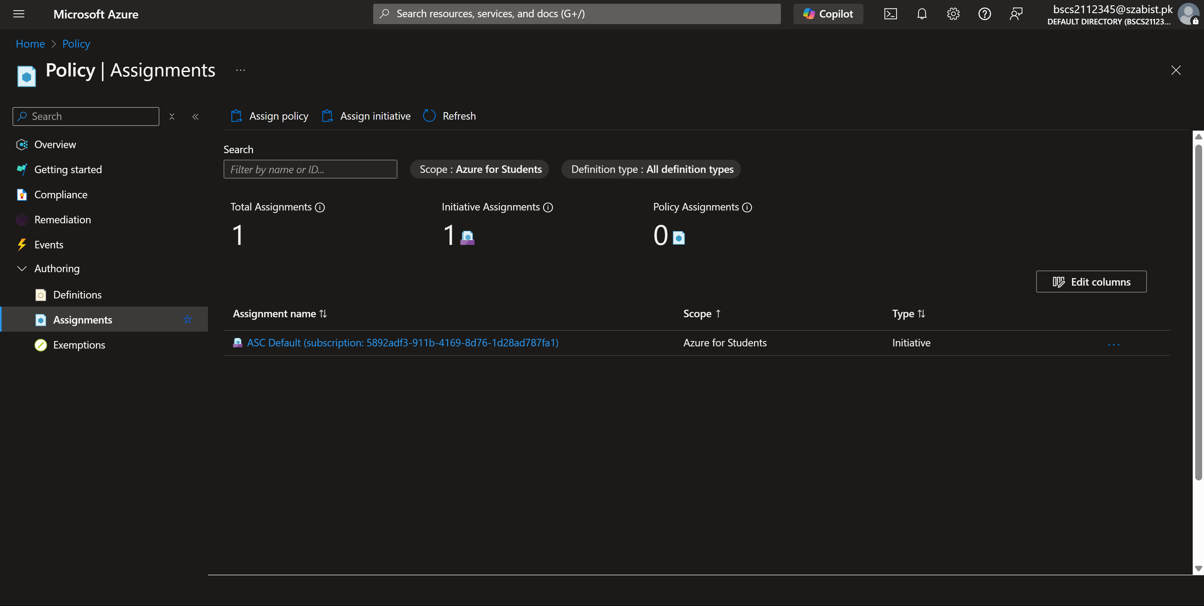
Step 2: The below screenshot shows the basic details are filled and the for policy I’ve chosen the rule/definition to require a tag and it’s value.
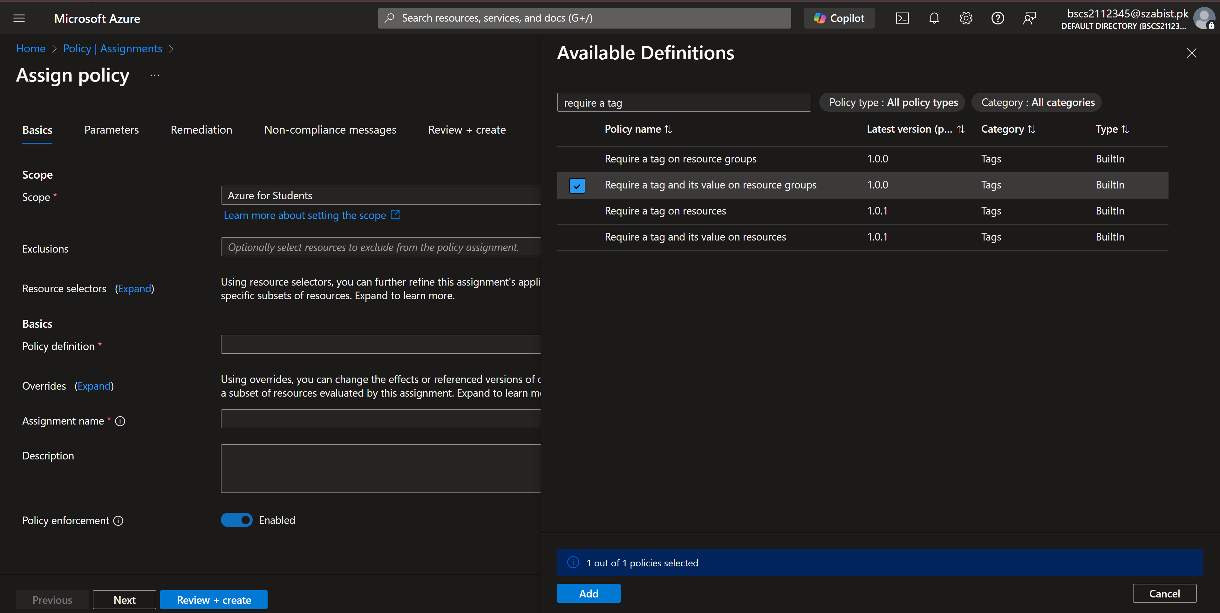

Step 3: Parameters are the tag key and value that is to be assigned to a resource group under this policy, it means that any resource/resource group that is to be created will need to have a tag key Company and value Contoso.
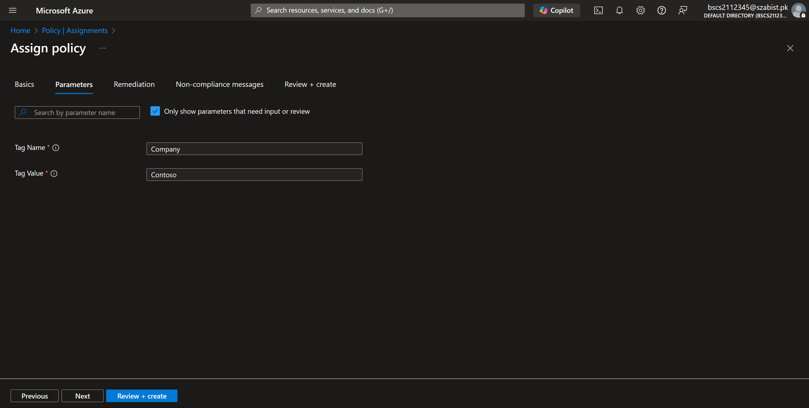
Step 4: Finally reviewing all the configurations and all validations have been, with this the policy is created by clicking on create. A policy can take some time to be effective.
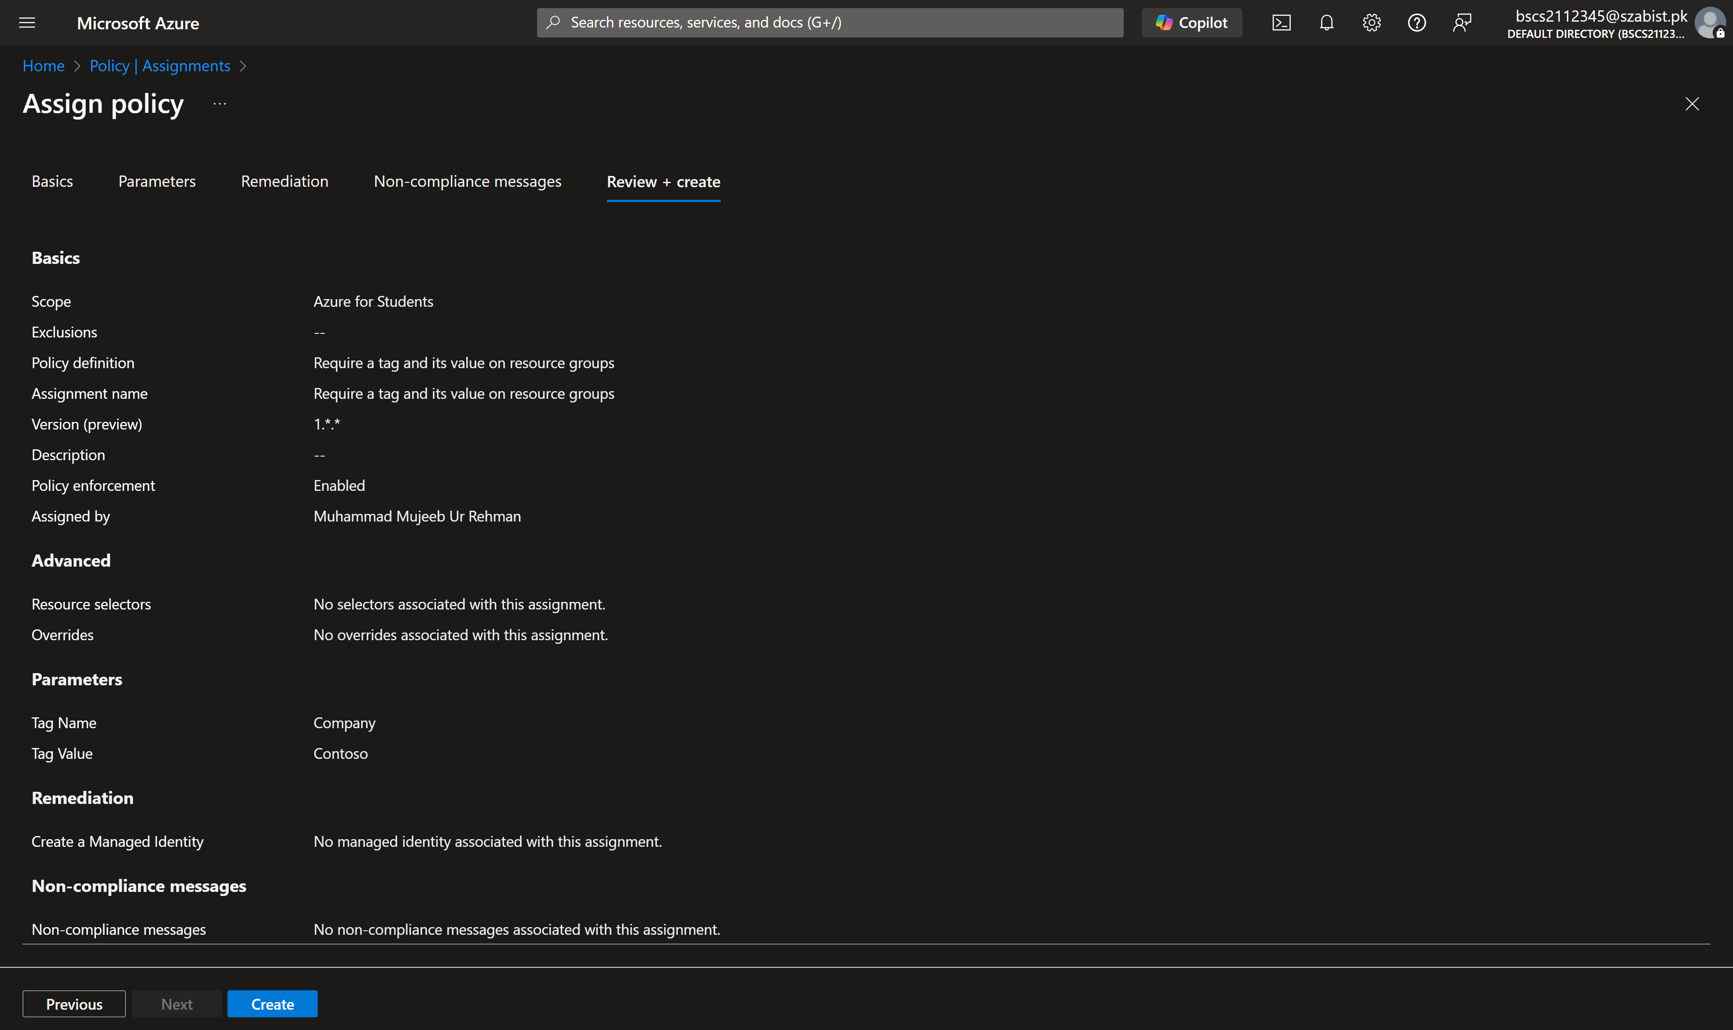

Step 5: After the policy is effective, to test it I’ve tried to create a storage account resource with no tags, and the validation has failed, the error message clearly states the reason for it as well that is our requirement of tag.
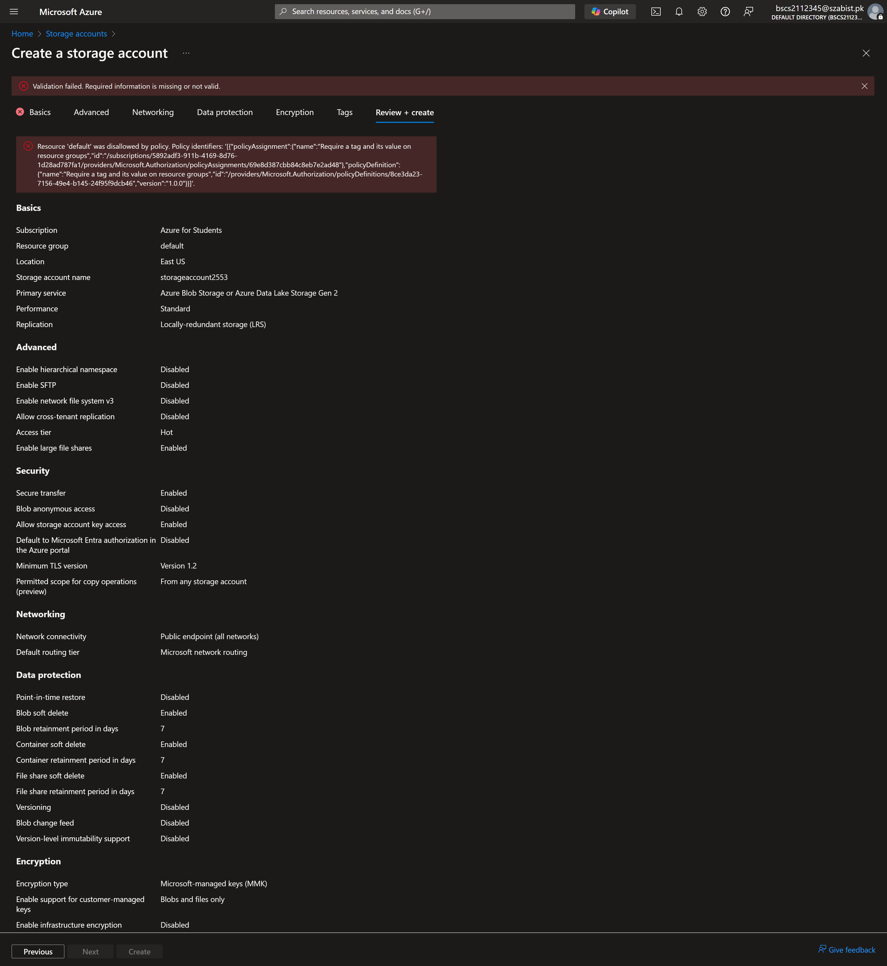

Step 6: Now after adding the tag, again I’ve reviewed it, this time we can see the tags and the validation has passed.
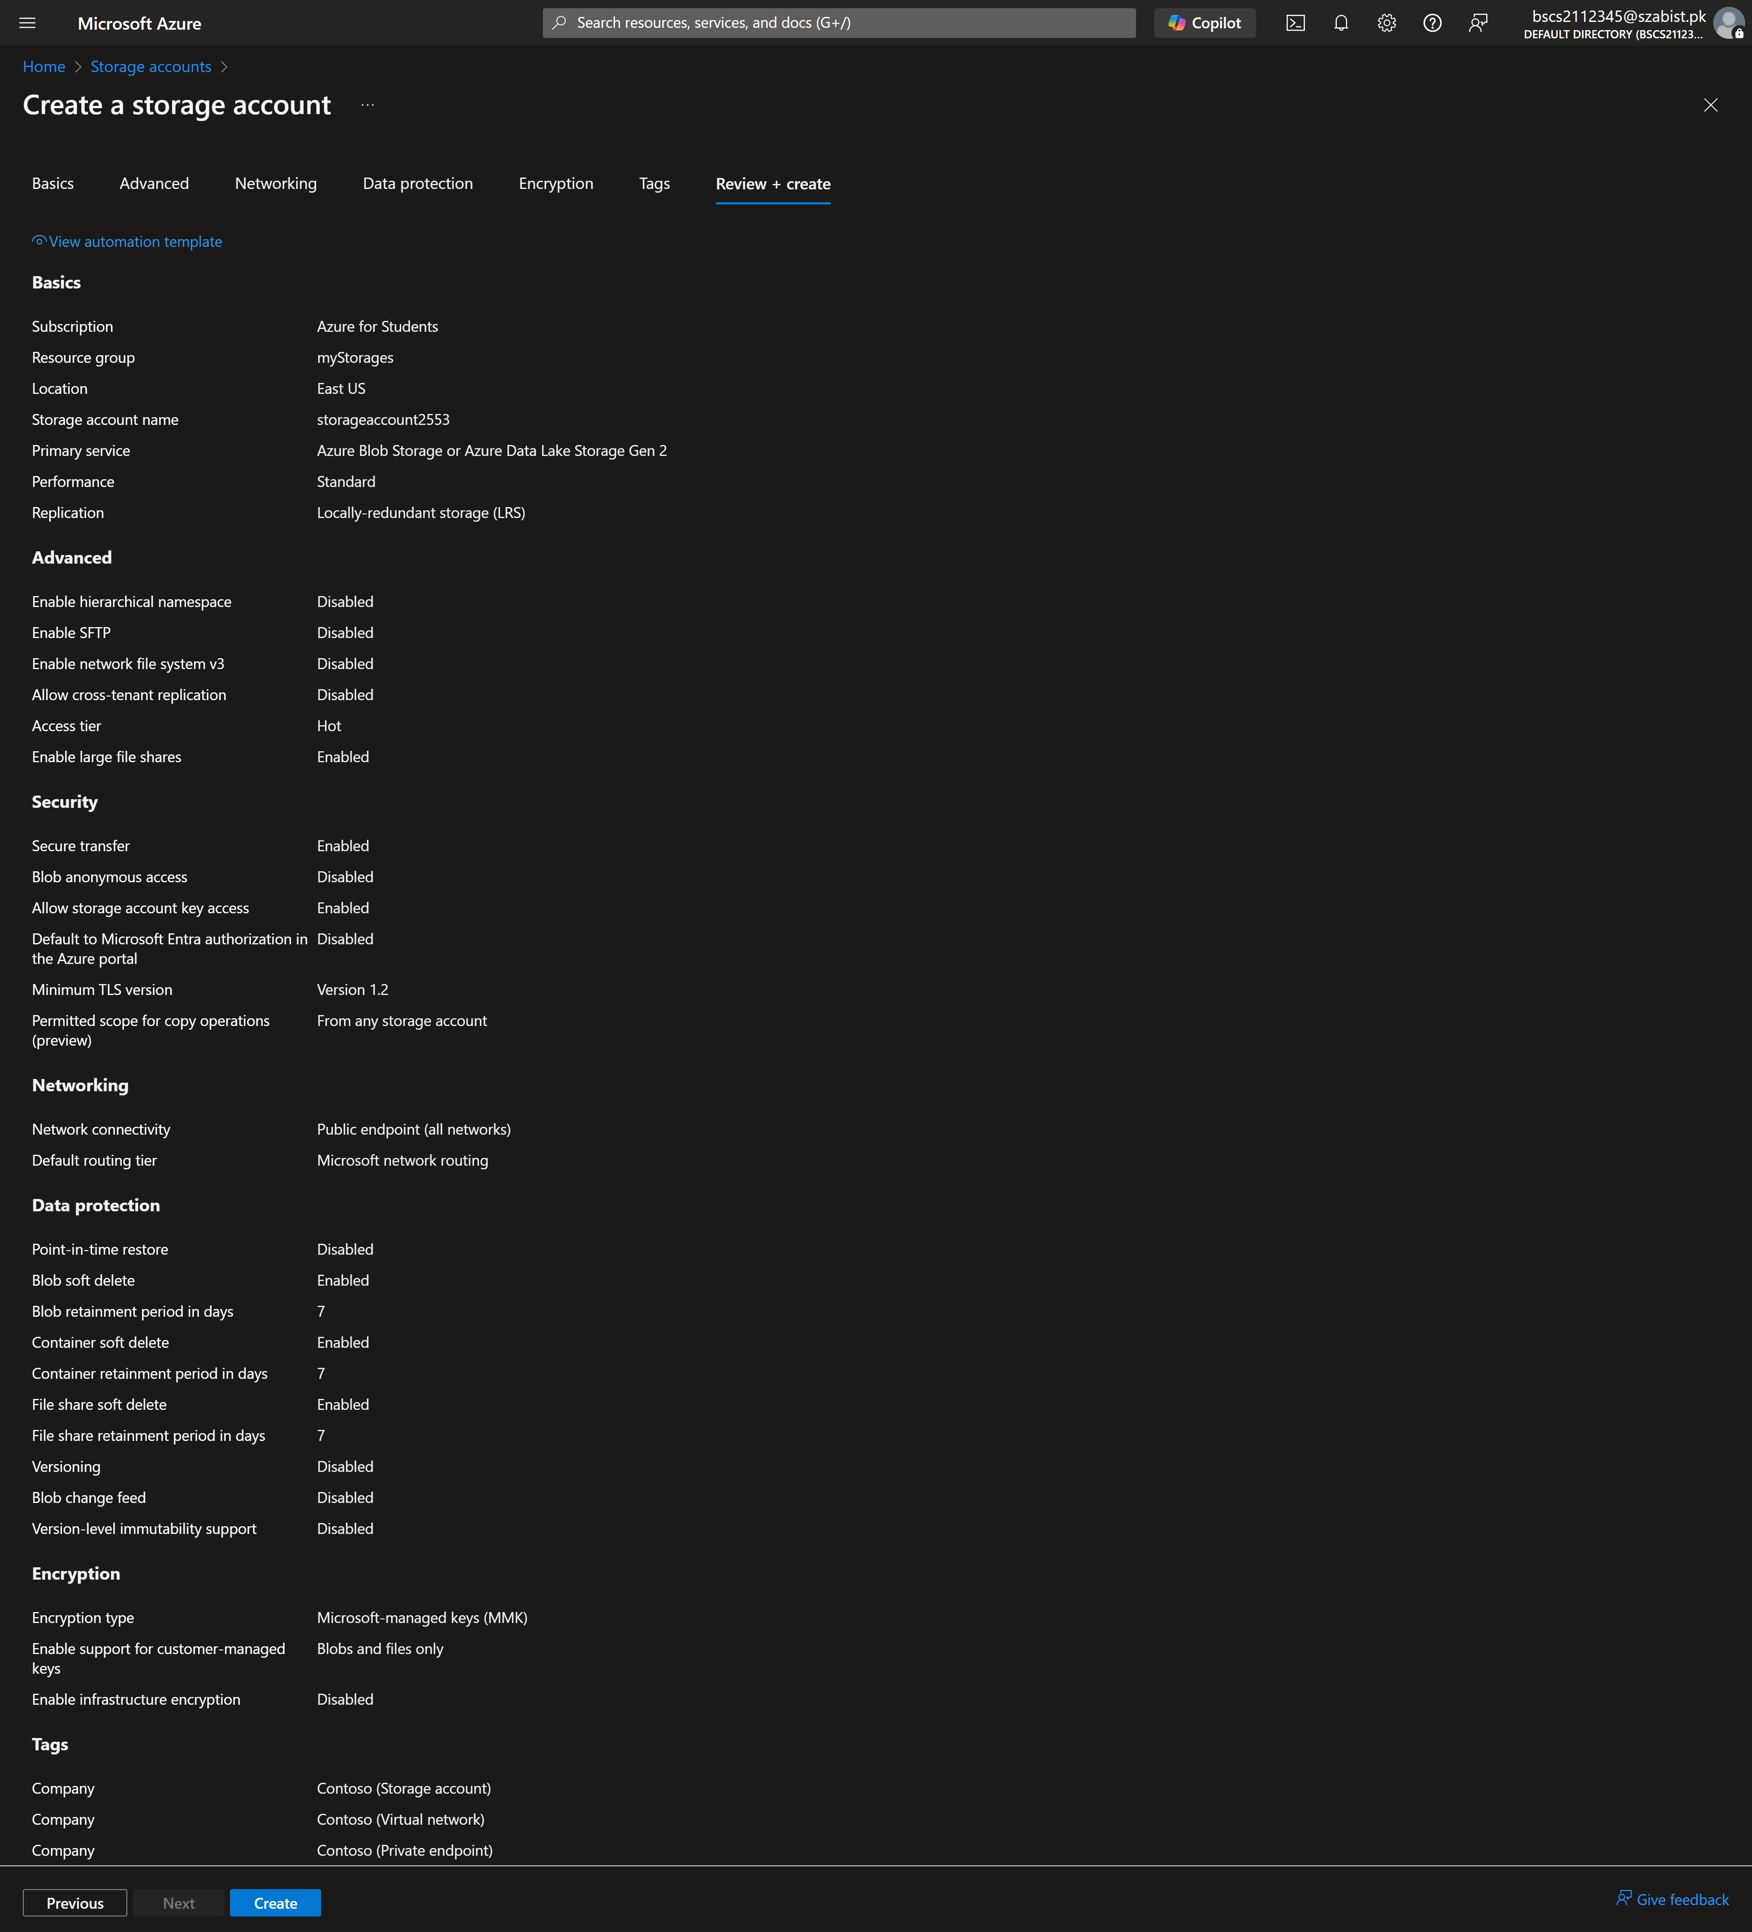

Step 7: Finally, the storage account is created with the tag assigned to it.
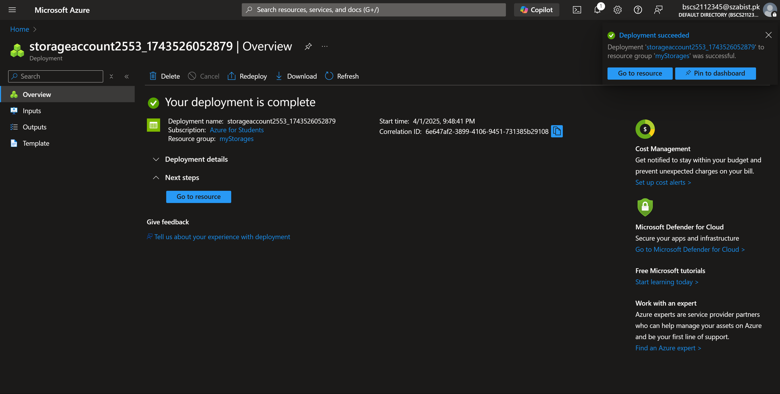

Task – 3: View all resources with a specific tag
Step 1: Tags can be understood as segregation in a organization, just as departments. Each department has their resources so in order to have better cost records we’ve applied the tags. And we can filter out to see only those resource that belong to the specific tag value.
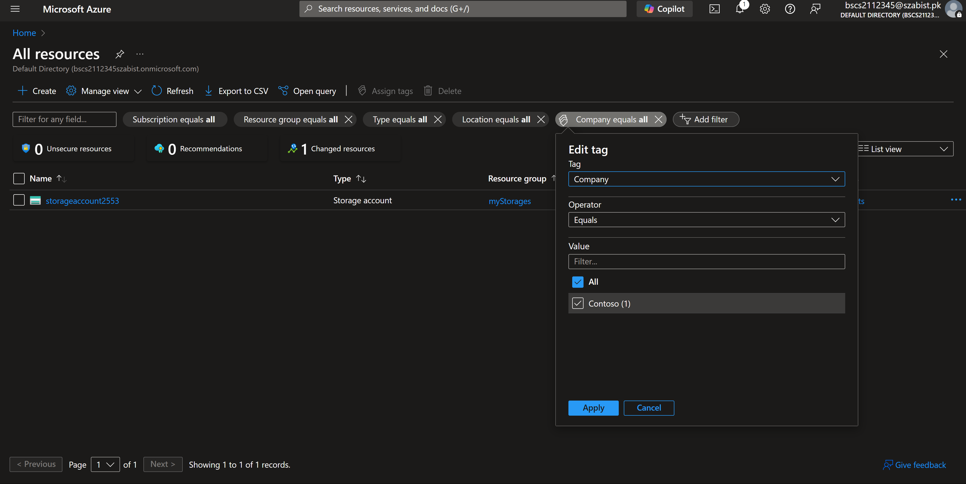

Task – 4: Delete the policy assignment
Step 1: Finally, our testing is done so we delete the policy so that it does not affect our future tasks.
